**TASK-8: FUNCTIONAL TESTING**

Functional testing is a type of software testing which is used to verify the functionality of the software application, whether the function is working according to the requirement specification. In functional testing, each function is tested by giving the value, determining the output and checking the actual output with the expected output. Functional testing performed as black box testing is presented to confirm that the functionality of system behaves as expected.

**STEPS IN FUNCTIONAL TESTING:**

* Requirement specification
* Test plan
* Design Test cases
* Traceability Matrix
* Execute Test Case
* Analysis to Examine Test case
* Defect Management

The main objective of functional testing is checking the functionality of the software system. It concentrates on basic **usability, accessibility, mainline function and error condition.**

**TYPES OF FUNCTIONAL TESTING:**

**SMOKE AND SANITY TESTING:**

Smoke and sanity test are almost the same in which is kind of quick and rough test done on application to verify whether the application is eligible for major testing or not.

If the quick and random test is conducted at test environment, then the test is called as smoke test. For example: Smoke testing verifies that the application launches successfully and will check that GUI is responsive.

If the quick and random test is conducted at production environment to confirm whether the application is eligible for acceptance testing or not is sanity testing.For Ex: Login is working fine, all the buttons are working correctly after clicking on the button navigation of the page is done or not.

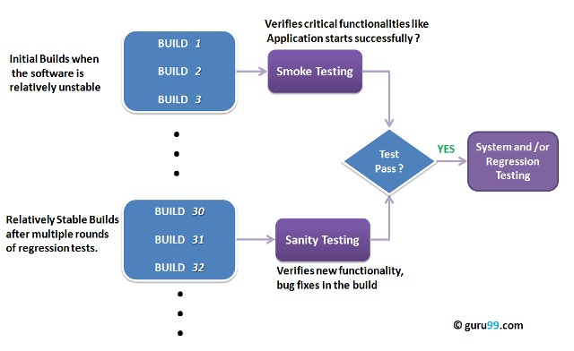

**RETESTING:**

Retesting is a type of testing performed to check the testcases that were unsuccessful in final execution are successfully passed after the defects fixed. Generally, when the tester finds the bug while testing the product or its component, he sends the bug to the developer and after the bug gets fixed the tester retests the application this testing is called retesting.

**REGRESSION TESTING:**

Regression testing is a type of testing that make sures that change in code doesn't change the existing features of the application. When the tester finds a bug in an application the tester informs the developer and after the developer clears the bug the tester retests all the parts to see whether there is an impact or not.

**FORMAL TESTING:**

Formal testing is a type of testing done based on predefined procedures and documents.

**INFORMAL TESTING:**

In formal testing is a type of testing which does not follow any predefined procedures and documents. The informal testing is also called as informal testing.

**RISK-BASED TESTING OR PRIORITY BASED TESTING:**

Risk based testing is a process of identifying all the business scenarios to be validated then, preorder the test execution. That is planning what needs to be tested first and what needs to be tested at last and executing in the same manner.

**EXPLORATORY TESTING:**

Exploring the application the application and add and modify the test cases for better testing is called exploratory testing.

**MONKEY/GORILLA/ZIGZAG/RATTEL/UNEVEN TESTING:**

If we test an application in a random way unevenly to identify tricky effects, then it's called monkey testing. It is a part of ad-hoc testing.

**END TO END TESTING:**

End to end is a process of identifying all core /important business scenarios in the system testing and testing these scenarios right from one end to other end including the data integration.

**RECOVERY TESTING:**

Recovery testing is used to define how well an application can recover from crashes, hardware failure, and other problems. The purpose of recovery testing is to verify the system's ability to recover from testing points of failure.

**FUNCTIONAL TESTING TOOLS:**

* Sahi
* SoapUI
* Watir
* Selenium
* Canoo Web Test
* Cucumber.

**Advantages of functional testing are:**

1. It produces a defect-free product.
2. It ensures that the customer is satisfied.
3. It ensures that all requirements are met.
4. It ensures the proper working of all the functionality of an application/software/product.
5. It ensures that the software/ product works as expected.
6. It ensures security and safety.
7. It improves the quality of the product.